EXAMPLE OF FRONT PAGE

Title: (Ex) Growth of Mycobacterium chimaera in heater–cooler units

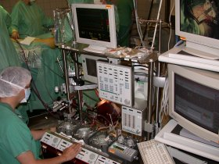

STUDENTS NAME
Location and year

A scientific thesis from the Scandinavian School of Cardiovascular Technology
Aarhus University Hospital
Denmark

Main supervisor/co-supervisor: Name, title, affiliation and contact information

